1. **Write a program to find the average of the marks of students. Use methods & constructors.**

**→**

import java.util.Scanner;

class Students{

double avg=0;

Students(int a[]){

for(int i=0;i<a.length;i++){

avg=avg+a[i];

}

}

}

public class Average{

public static void main(String args[]){

int i;

System.out.print("Enter number of subjects : ");

Scanner sc=new Scanner(System.in);

int n = sc.nextInt();

int[] a = new int[n];

System.out.println("Enter marks : ");

for( i=0;i<n;i++){

a[i]=sc.nextInt();

}

Students c = new Students(a);

System.out.print("Average of (");

for(i=0;i<n-1;i++){

System.out.print(a[i]+",");

}

System.out.println(a[i]+") : "+c.avg/n);

}

}

**OUTPUT :**

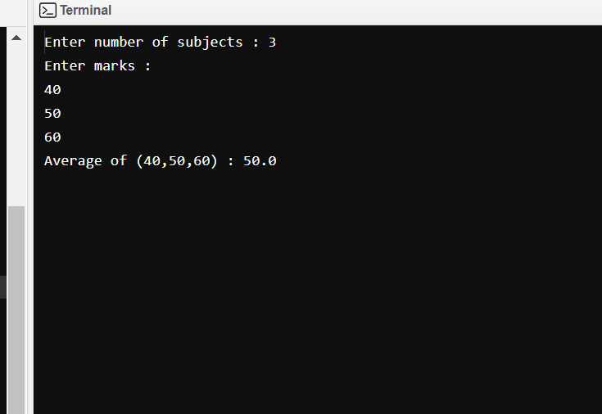

1. **Create a class Employee that includes three instance variables – a first name, a last name & a monthly salary. Provide a constructor that initializes three variables. Provide a set & get method for each instance variable. If the monthly salary is not positive, do not set its value. Write a test application named EmployeeTest that demonstrates class Employee’s capabilities. Create two Employee objects & display each object’s yearly salary. Then give each employee a 10% raise and display each Employee’s yearly salary again.**

**→**

import java.util.Scanner;

class Employee{

String id, fName, lName, ID;

double salary;

static String CEO;

Scanner sc = new Scanner (System.in);

public Employee (){

id = "2023";

}

public void setName (){

System.out.print("Enter first name : ");

fName = sc.next();

System.out.print("Enter last name : ");

lName = sc.next();

}

public void setSalary (){

System.out.print("Enter salary : ");

salary = sc.nextDouble();

}

public void setId (){

System.out.print("Enter employee id : ");

ID = sc.next();

}

public void getName (){

System.out.println("Employee id : "+id+ID);

System.out.println("Employee name : "+fName+" "+lName);

}

public void getSal (){

if (salary<0){

System.out.println("Salary : "+salary);

}

else{

System.out.println("Salary : "+salary);

}

}

public void calcSal (){

double hike;

hike = salary * 0.10;

salary = (12 * salary) + hike;

System.out.println("After 10% hike in salary the yearly salary is : "+salary);

}

}

public class Emp{

public static void main (String[] args){

int i, no;

Employee.CEO = "Ms. XYZ";

Employee[] obj = new Employee[10];

Scanner input = new Scanner (System.in);

System.out.print("Enter no. of employees : ");

no = input.nextInt();

for (i = 1; i <= no; i++) {

obj[i] = new Employee();

System.out.print("Enter details of employee "+i+" : \n");

obj[i].setName();

obj[i].setSalary();

obj[i].setId();

}

System.out.println("____Employee Details___");

for (i = 1; i <= no; i++) {

System.out.println("Employee "+i);

obj[i].getName();

obj[i].getSal();

obj[i].calcSal();

}

}

}

**OUTPUT :**

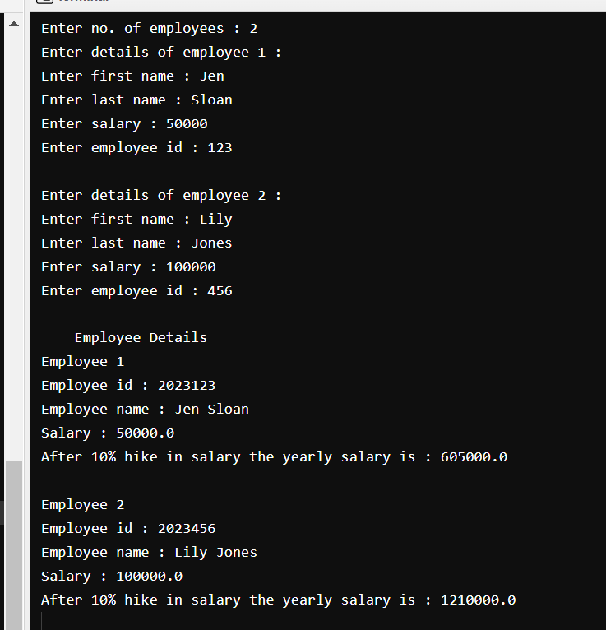

1. **Create a class called Invoice that a hardware store might use to represent an item sold at the store. An Invoice should include four pieces of information as an instance variable – a part number, a part description, a quantity of the item being purchased & a price per item. Your class should have a constructor which initializes the four instance variables. Provide a set & get method for each instance variable. In addition, provide a method named getInvoiceAmount that calculates the invoice amount, then returns the amount as a double value. If the quantity is not positive, it should be set to 0. If the price per item is not positive, it should be set to 0.0. Write a test application named InvoiceTest that demonstrates class Invoice’s capabilities.**

**→**

import java.util.Scanner;

class Invoice{

int no, qty;

String des;

double prize;

double amount;

Scanner sc = new Scanner(System.in);

Invoice() {

no = 0000;

qty = 0;

des = "abc";

prize = 0000;

}

void get_no() {

System.out.print("Enter part's no. : ");

no = sc.nextInt();

}

void get_des() {

System.out.print("\nEnter part's description : ");

des = sc.next();

}

void get_qty() {

System.out.print("\nEnter part's quantity : ");

qty = sc.nextInt();

}

void get_prize() {

System.out.print("\nEnter part's prize : Rs.");

prize = sc.nextDouble();

}

void getInvoiceAmount() {

if (qty <= 0 && prize <= 0) {

amount = 0;

}

else {

amount = qty * prize;

}

}

void bill()

{

System.out.print(des+"\n\t"+no+"\t"+qty+" pcs.\tRs. "+prize+"\tRs."+amount);

}

}

public class InvoiceTest {

public static void main(String[] args) {

int items, i;

double total = 0;

Scanner sc = new Scanner(System.in);

Invoice[] obj = new Invoice[10];

System.out.print("Enter no. of items : ");

items = sc.nextInt();

for (i = 1; i <= items; i++) {

obj[i] = new Invoice();

System.out.print("\n\nPart "+i+":\n");

obj[i].get_no();

obj[i].get_des();

obj[i].get_qty();

obj[i].get_prize();

obj[i].getInvoiceAmount();

}

System.out.println("----------------------Hardware Store-----------------------\n\n");

System.out.println("\nPart name\tPart no.\tQuantity\tPrize\tAmount\n");

for (i = 1; i <= items; i++) {

obj[i].bill();

total = obj[i].amount + total;

} System.out.println("\n__________________________________________________\n");

System.out.print("Total billing amount : \t\t\tRs. " + total);

}

}

**OUTPUT :**

